Step 1: Search MySQL Workbench

Step 2: Click on localhost

Step 3: Right Click in Schemas then create Schema and Give Name

Step 4: Open schema then right click on tables and create table

Step 5: Write Following Code

import tkinter as tk

from mysql.connector import connect, Error

# Database connection configuration

db_config = {

'host': '127.0.0.1',

'user': 'root',

'password': 'manager',

'database': 'sys'

}

def execute_query(query, values=None):

try:

with connect(**db_config) as connection:

cursor = connection.cursor()

if values:

cursor.execute(query, values)

else:

cursor.execute(query)

connection.commit()

return cursor.lastrowid

except Error as e:

print(f"Error executing query: {e}")

def insert_data():

id = entry_id.get()

name = entry_name.get()

email = entry_email.get()

query = "INSERT INTO student (id,name, email) VALUES (%s, %s,%s)"

values = (id,name, email)

execute_query(query, values)

def update_data():

id = entry_id.get()

name = entry_name.get()

email = entry_email.get()

query = "UPDATE student SET name = %s, email = %s WHERE id = %s"

values = (name, email,id)

execute_query(query, values)

def delete_data():

name = entry_name.get()

query = "DELETE FROM student WHERE name = %s"

values = (name,)

execute_query(query, values)

def select_data():

try:

with connect(**db_config) as connection:

query = "SELECT * FROM student"

cursor = connection.cursor()

cursor.execute(query)

rows = cursor.fetchall()

for row in rows:

print(row) # You can modify this to display the data in your Tkinter application

except Error as e:

print(f"Error executing query: {e}")

# Tkinter application setup

root = tk.Tk()

label_id = tk.Label(root, text="ID")

label_id.grid(row=0, column=0)

entry_id = tk.Entry(root)

entry_id.grid(row=0, column=1)

label_name = tk.Label(root, text="Name")

label_name.grid(row=1, column=0)

entry_name = tk.Entry(root)

entry_name.grid(row=1, column=1)

label_email = tk.Label(root, text="Email")

label_email.grid(row=2, column=0)

entry_email = tk.Entry(root)

entry_email.grid(row=2, column=1)

button_insert = tk.Button(root, text="Insert", command=insert_data)

button_insert.grid(row=3, column=0)

button_update = tk.Button(root, text="Update", command=update_data)

button_update.grid(row=3, column=1)

button_delete = tk.Button(root, text="Delete", command=delete_data)

button_delete.grid(row=3, column=2)

button_select = tk.Button(root, text="Select", command=select_data)

button_select.grid(row=3, column=3)

root.mainloop()

**OUTPUT:-**

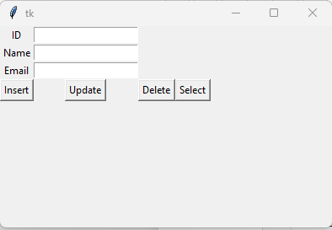

from flask import Flask

app = Flask (__name__)

@app.route("/")

@app.route("/home")

def home():

return "<h2>This Is My Home Page</h2>"

if __name__=='__main__':

app.run()

OUTPUT:-

